

E-Commerce Application

ARCHITECTURALLY SIGNIFICANT REQUIREMENT DOCUMENT



July 3, 2023

Arch Neo 2023, Batch 2, Group -2

Ramesh Selvam,

Shubhanjan Banerjee,

Chiranjit Show,

Rama Krishnan Kumar Poraiyan,

Naveen Narendula,

Bhargav Iyer

**Version 2.0**

Table of Contents

Introduction 3

Documentation Purpose and Scope 3

Product Perspective: 3

Product Scope: 3

Platform Development 3

User Registration and Authentication 4

Product Catalogue Management 4

Shopping Cart Functionality 4

Checkout and Payment 4

Order Tracking 4

Account Management 4

Notification System 4

Integration with Supply Chain 4

Performance and Scalability 5

Security and Privacy 5

Localization 5

Intended Audience 6

Business Owners and Management 6

Product Managers 6

Software Architects 6

Developers and Engineers 6

Quality Assurance/Testers 6

User Experience (UX) Designers 6

Business Context 7

Business Overview 7

Expansion into Online Space 7

Objective 7

Reducing Dependence on Offline Channels 7

Simplicity and Timely Deliveries 7

Target Customer Base 7

Stakeholders 8

Technical Constraints 10

Business Constraints 12

Quality attribute requirements 13

Use Case 16

User searches for products 18

Repository branching strategy: 21

Feature Branching: 21

Functionalities 22

System Landscape View: 23

Context View 24

Container View 25

Component View 26

Deployment View (Development) 27

ER Diagram: 29

# Introduction

## Documentation Purpose and Scope

The ecommerce system provides a platform for conducting sales of a wide variety of goods and provides a way of bringing inventory management and customers on an online platform to conduct transactions in a secure manner across the globe. It is implemented as an online enterprise. This system provides an avenue for customers to shop from a wide variety of products online. It also provides a platform where they can update their inventory to the system for customers to view and purchase. The biggest advantage of the service is the comfort it brings with remote usage. The ability to compare various price ranges, brands and even customer reviews and experiences provides for a more honest/depth understand.

The vision of the ecommerce system is to be able to provide a smooth and user-friendly platform for customers to select from a wide range of products conveniently and purchased and to cater to the needs of both customers and inventory manager.

## Product Perspective:

The system includes the user subsystem as well the inventory subsystem. The ecommerce platform provides an outstanding way of bringing and customers on an online platform to make purchases in an efficient and secure manner irrespective of the distance between the two. It is a platform for customers to shop items online without having to visit a store physically, and a platform for inventory manager to sell their items online without having to meet the customers physically or have a physical store set up for his products. This system is a one stop for customers to shop from millions of products online. The inventory manager uploads his listing to the system and the customers browse from these items and purchase them.

## Product Scope:

### Platform Development

Develop a web-based e-commerce platform that allows customers to browse and purchase furniture and appliances online. The ecommerce system provides a platform for conducting sales of a wide variety of goods and provides a way of bringing inventory management and customers on an online platform to conduct transactions in a secure manner across the globe. It is implemented as an online enterprise.

### User Registration and Authentication

Implement a user registration and authentication system to allow users to create accounts, log in, and securely access the platform.

### Product Catalogue Management

Create a searchable product catalogue with categories, allowing users to browse and search for specific furniture and appliances. The ability to compare various price ranges, brands and even customer reviews and experiences provides for a more honest/depth understand. The vision of the ecommerce system is to be able to provide a smooth and user-friendly platform for customers to select from a wide range of products conveniently and purchased and to cater to the needs of both customers and inventory manager.

### Shopping Cart Functionality

Develop a shopping cart feature that enables users to add products, modify quantities, and proceed to checkout. This system provides an avenue for customers to shop from a wide variety of products online.

### Checkout and Payment

Implement a secure and user-friendly checkout process, allowing customers to provide delivery addresses and make payments online or through cash on delivery (COD).

### Order Tracking

Develop a real-time order tracking system that provides updates to customers regarding the status and delivery date of their orders.

### Account Management

Include functionality for users to manage their profiles, view order history, and access invoices.

### Notification System

Implement a notification system to send timely updates to customers, such as order confirmations, payment notifications, and delivery status updates.

### Integration with Supply Chain

Integrate the platform with the existing delivery and supply chain management systems to facilitate order processing and fulfilment. It also provides a platform where they can update their inventory to the system for customers to view and purchase. The biggest advantage of the service is the comfort it brings with remote usage.

### Performance and Scalability

Design and optimize the architecture to ensure the platform can handle concurrent user traffic, a growing product catalogue, and deliver responsive user experiences.

### Security and Privacy

Implement security measures, including secure payment processing, user data protection, and adherence to data privacy regulations.

### Localization

Support multiple languages and regional preferences to cater to users from different regions and enhance their shopping experience.

## Intended Audience

### Business Owners and Management

The project stakeholders who have initiated the project and hold the responsibility for its success. They would be interested in understanding how the platform will align with the business goals and contribute to its growth.

### Product Managers

Individuals responsible for overseeing the development and delivery of the e-commerce platform. They need to be familiar with the project scope, requirements, and progress to ensure that the platform meets the desired functionality and objectives.

### Software Architects

Architects who are responsible for designing the system's architecture and ensuring its scalability, security, and performance. They would be interested in the architectural aspects and decisions related to the platform development.

### Developers and Engineers

The development team involved in building the e-commerce platform. They need to have a clear understanding of the project scope to guide their coding, implementation, and testing activities.

### Quality Assurance/Testers

Individuals responsible for testing the platform to ensure its functionality, usability, and performance meet the defined requirements. They need to be aware of the project scope to design effective test cases and validate the platform against the specified criteria.

### User Experience (UX) Designers

Designers responsible for creating an intuitive and user-friendly interface. They should be aware of the project scope to align the user experience with the intended goals and requirements.

## Business Context

The business context for the e-commerce platform development project can be described as follows:

### Business Overview

The company is a new start-up operating in the Indian region, primarily engaged in selling furniture and appliances through offline channels. They have an established delivery and supply chain infrastructure in place.

### Expansion into Online Space

The company aims to expand its operations in the online space by developing an e-commerce platform. The platform will allow customers to purchase a variety of products, including furniture and appliances, online.

### Objective

The primary objective is to establish a user-friendly e-commerce platform that enables customers to browse, select, and purchase products online, leveraging the company's existing delivery and supply chain capabilities.

### Reducing Dependence on Offline Channels

The company seeks to decrease reliance on traditional offline channels and reduce the costs associated with commission fees charged by existing marketplaces.

### Simplicity and Timely Deliveries

The company wants to avoid overloading the platform with excessive features such as wallets and coupons to ensure a streamlined user experience and prevent any delays in order processing and delivery.

### Target Customer Base

The platform will cater to customers residing in Tier 2 and Tier 3 cities in India. The availability of delivery services in specific pin codes will be communicated to users as necessary.

Overall, the business context highlights the company's desire to establish an independent e-commerce platform that enables customers to conveniently purchase furniture and appliances online. The emphasis is on simplicity, timely deliveries, and leveraging the existing delivery and supply chain infrastructure to expand the company's reach in the online market.

### Stakeholders

The stakeholders for the e-commerce platform development project can include:

#### Business Owners and Management

The individuals who have a vested interest in the success of the project, as they are responsible for the overall business strategy, investment decisions, and project governance.

#### Product Managers

Individuals who are accountable for overseeing the development of the e-commerce platform, aligning it with business goals, and ensuring it meets the needs of the target market.

#### Software Architects

Architects responsible for designing the system's architecture, making technology decisions, and ensuring scalability, performance, and security of the platform.

#### Developers and Engineers

The development team tasked with building the e-commerce platform, including front-end and back-end developers, who will be responsible for coding, testing, and implementing the required functionality.

#### Quality Assurance/Testers

Individuals responsible for testing the e-commerce platform to ensure it meets quality standards, functions correctly, and provides a seamless user experience.

#### User Experience (UX) Designers

Designers who are involved in creating an intuitive and user-friendly interface for the e-commerce platform, focusing on usability, accessibility, and visual design.

#### Supply Chain and Logistics Managers

Individuals responsible for managing the company's supply chain and logistics operations. They will be involved in integrating the e-commerce platform with existing systems to ensure smooth order processing and timely deliveries.

#### Customer Support Representatives

Representatives who will handle customer inquiries, order issues, and provide support through various channels such as chat, email, or phone.

#### End Users

The ultimate users of the e-commerce platform—customers who will visit the website, browse products, make purchases, and interact with the platform. Their feedback and satisfaction are essential for the success of the project.

It is important to identify and engage these stakeholders throughout the project to gather requirements, ensure alignment with business objectives, obtain feedback, and address any concerns or issues that may arise during the development process.

## Technical Constraints

The technical constraints for the e-commerce platform development project can include:

#### Technology Stack

The project may have constraints related to the selection of technology stack or platforms to be used for development. These constraints could be influenced by existing infrastructure, organizational preferences, compatibility requirements, or third-party integrations.

#### Scalability

The platform should be designed to handle increasing user traffic and a growing product catalogue. Scalability constraints may include considerations for database performance, server load balancing, caching mechanisms, and horizontal or vertical scaling options.

#### Performance

The platform should be designed to deliver optimal performance to ensure fast response times, quick page load times, and smooth user interactions. Constraints related to performance may involve optimizing code, database queries, network latency, and minimizing resource usage.

#### Security

The e-commerce platform must adhere to industry-standard security practices to protect user data, prevent unauthorized access, and safeguard against potential threats such as data breaches or injection attacks. Constraints may include using encryption, secure authentication mechanisms, and implementing security protocols.

#### Integration with Third-Party Systems

The platform may need to integrate with external systems such as payment gateways, inventory management systems, or customer relationship management (CRM) software. Constraints can arise from compatibility requirements, API availability, data synchronization, and maintaining data integrity during integration.

#### Mobile Responsiveness

The e-commerce platform may require mobile responsiveness to ensure a seamless user experience across various devices and screen sizes. Constraints may include designing responsive layouts, optimizing images and media, and ensuring compatibility with different mobile platforms and browsers.

#### Data Management

Constraints related to data management may include data storage, retrieval, and backup mechanisms. Compliance with data privacy regulations, data encryption, and proper handling of personally identifiable information (PII) may also impose constraints.

#### Cross-Browser Compatibility

The e-commerce platform should be compatible with popular web browsers to ensure consistent functionality and appearance across different browser versions and platforms. Constraints may involve testing and resolving any compatibility issues that arise.

#### Localization

If the platform is intended to serve customers from different regions or countries, constraints related to localization may include support for multiple languages, currencies, and regional preferences.

#### Development Time and Resource Constraints

The project may have limitations on development time, available resources, or budget. These constraints can influence the scope, prioritization of features, and overall development timeline.

## Business Constraints

The business constraints for the e-commerce platform development project can include:

#### Budget

The availability of financial resources allocated to the project can impose constraints on the scope, timeline, and resources available for development.

#### Timeframe

The project may have specific time constraints, such as a desired launch date or market opportunity window, which can impact the development timeline and prioritization of features.

#### Resource Availability

Constraints related to the availability of skilled personnel, development teams, or external vendors can impact the project's execution and may require adjustments to the scope or timeline.

#### Legal and Regulatory Compliance

The e-commerce platform must adhere to applicable laws, regulations, and industry standards, such as consumer protection, data privacy, and taxation requirements. Compliance constraints may influence the design, functionality, and operational aspects of the platform.

#### Competitive Landscape

The business may face constraints imposed by the competitive market landscape. These constraints can include the need to differentiate from competitors, offer unique features or pricing strategies, and respond to market trends or customer demands.

#### Existing Infrastructure

Constraints can arise from the need to integrate the e-commerce platform with existing systems, databases, or infrastructure. Compatibility and interoperability considerations may need to be addressed to ensure a seamless transition and minimize disruptions to the business operations.

#### Customer Expectations

The platform should meet the expectations of the target customers in terms of usability, convenience, and functionality. Understanding customer needs and aligning the platform with their expectations may impose constraints on the design and development process.

#### Brand Identity

The e-commerce platform should align with the brand identity, values, and positioning of the business. Constraints related to branding guidelines, visual design, and user experience may need to be considered during the development process.

#### Operational Considerations

Constraints related to operational aspects, such as inventory management, order fulfilment, customer support, and supply chain logistics, may need to be taken into account to ensure the platform can effectively support the business operations.

#### Vendor or Partner Constraints

If the business relies on third-party vendors or partners for specific services, constraints may arise from their capabilities, availability, pricing models, or contractual agreements.

Understanding and addressing these business constraints is crucial for successfully delivering an e-commerce platform that aligns with the business goals, meets customer expectations, and operates within the defined limitations.

## Quality attribute requirements

Quality attribute requirements, also known as non-functional requirements, describe the desired qualities and characteristics of the e-commerce platform beyond its core functionality. These requirements are essential for ensuring the platform's performance, usability, security, and other key aspects meet user expectations and business needs. Here are some examples of quality attribute requirements for the e-commerce platform:

#### Performance

The platform should have fast response times and quick page load speeds to provide a seamless user experience. For example, pages should load within a certain time limit (e.g., 2 seconds) across various devices and network conditions.

#### Scalability

The platform should be designed to handle increasing user traffic and a growing number of products without compromising performance. It should support horizontal and vertical scaling to accommodate future growth.

#### Reliability

The platform should be highly reliable, with minimal downtime and system failures. It should have a robust error-handling mechanism and graceful degradation in case of unexpected issues.

#### Security

The platform should adhere to industry-standard security practices to protect user data, prevent unauthorized access, and safeguard against potential threats such as data breaches and cyberattacks.

#### Usability

The platform should be intuitive and easy to use, ensuring that users can navigate through the website, search for products, and make purchases without confusion or frustration.

#### Accessibility

The platform should be accessible to users with disabilities, conforming to accessibility standards such as WCAG (Web Content Accessibility Guidelines).

#### Compatibility

The platform should be compatible with different web browsers, operating systems, and devices to provide a consistent experience to all users.

#### Maintainability

The platform should be designed and implemented in a way that facilitates easy maintenance, updates, and enhancements to accommodate future changes or new features.

#### Data Integrity and Privacy

The platform should ensure the integrity of user data, prevent data corruption, and protect user privacy by adhering to data privacy regulations and best practices.

#### Performance under Load

The platform should be tested for its ability to handle peak user loads without performance degradation. Load testing should be performed to assess its performance and scalability.

#### Response Time for Payment Processing

The payment processing system should have a defined response time for completing transactions, ensuring quick and efficient payment processing for customers.

#### Order Fulfilment Time

The time between order placement and delivery should be specified to manage customer expectations and ensure timely deliveries.

#### Customer Support Response Time

The expected response time for customer support inquiries and issue resolution should be defined to provide excellent customer service.

Each of these quality attribute requirements plays a critical role in shaping the overall user experience and performance of the e-commerce platform. By defining and adhering to these requirements, the platform can meet user expectations, gain customer trust, and contribute to the success of the business.

## Use Case

User Registration

*Scenario of Registration Process*

* User can enter FirstName, Middle Name, Last Name, Email Id, Phone Number, Password.
* User can click on registration Button.
* Validation can be done at front end and backend code.
* If validation successfully done, then user can see registration success and login page link/button.
* If validation failed, then user can see validation error message on registration page.

User Login

*Scenario of Login Process*

* User can enter Username and password, username can be

email Id or Phone Number.

* If user enter valid details, then he can see home page of ecommerce application.
* If validation failed, user could see login failed error on Login page.

### User searches for products

#### Scenario: Successful product search

* Given that the customer is on the home page
* When the customer enters a valid search query for a product
* Then the system should display a list of products that match the search query
* And the displayed products should include the product name, image, price, and relevant details
* And the displayed products should be relevant and accurately match the search query

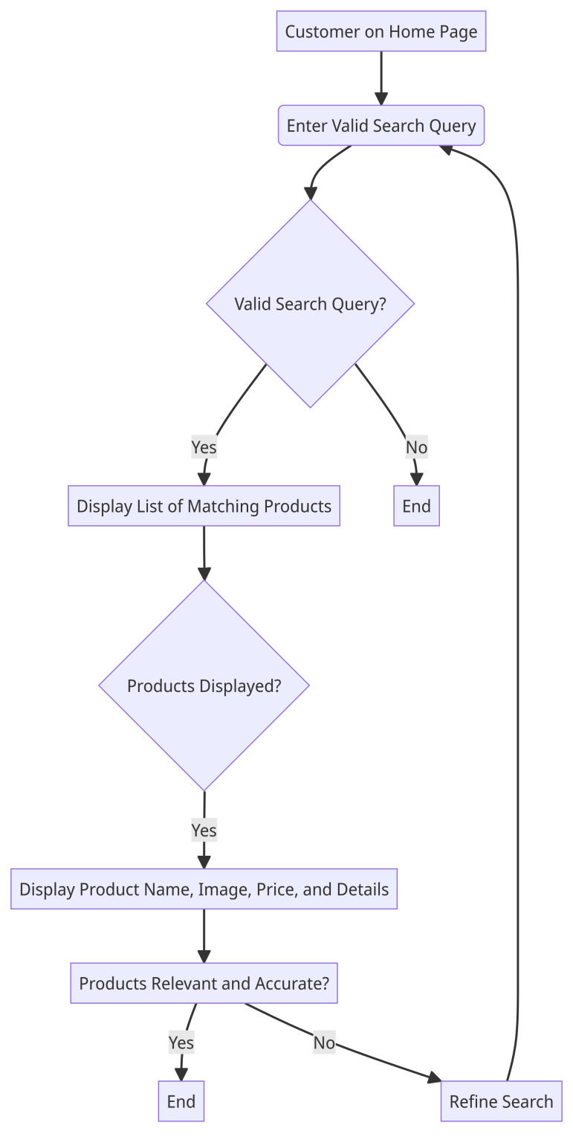

#### Scenario: No matching results for the search query

* Given that the customer is on the home page
* When the customer enters a search query for a product that does not exist in the system
* Then the system should display a message indicating that no matching products were found
* And the system should not display any products in the search results

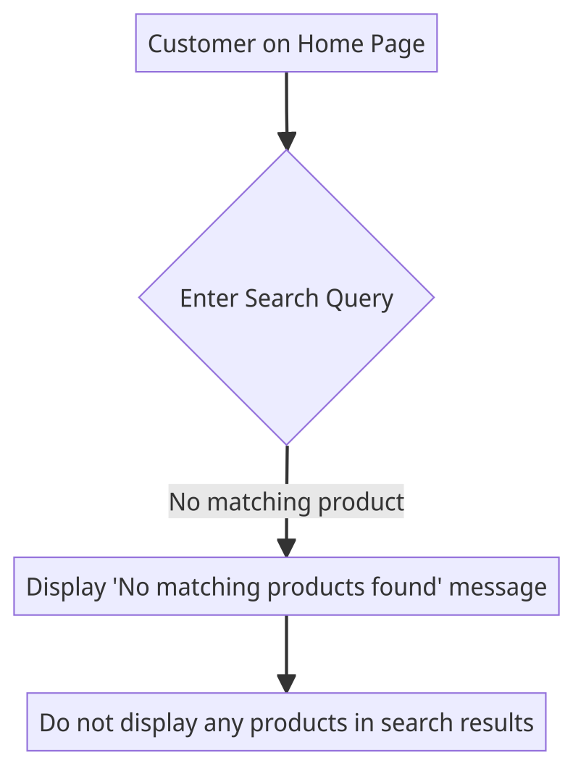

#### Scenario: Handling empty search query

* Given that the customer is on the home page
* When the customer performs a search without entering any search query
* Then the system should display a message indicating that a search query is required
* And the system should not perform a search or display any products in the search results

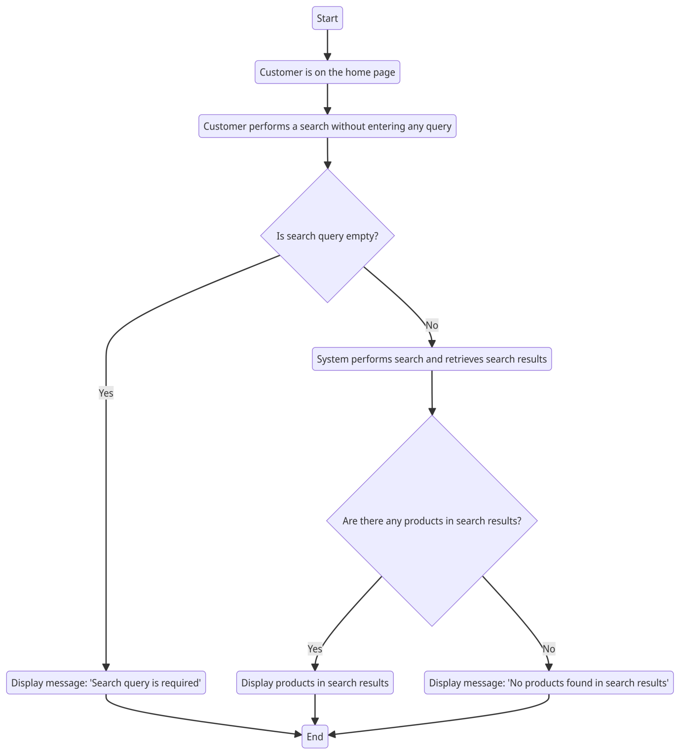

# Repository branching strategy:

We will maintain our repository in combination of the following strategies:

### Feature Branching:

* Feature Branching is a commonly used workflow that involves creating a new branch for a specific feature or change in the codebase.
* This allows developers to work on the feature independently without affecting the main branch.
* When the feature is complete, it can be merged back into the main branch through a pull request.
* The pull request allows other team members to review the changes and suggest modifications or improvements before merging the feature into the main branch.

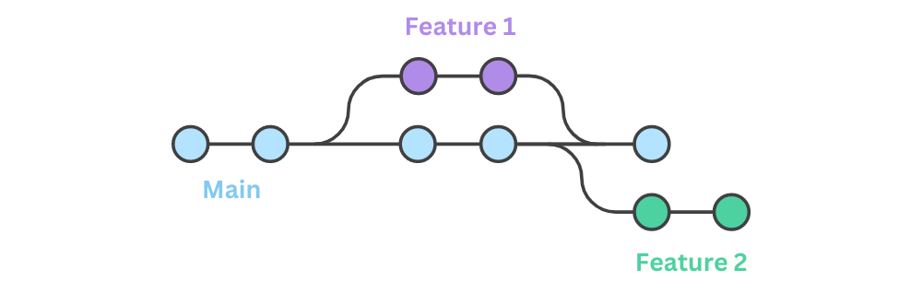

### Functionalities

Enlisted below are all the major functions supported by the online shopping system along with the user classes.

● Register: for customers

● Login: for customers

● Logout: for customers

● View Account Details: for customers

● Edit Account Details: for customers

● Search item: for customers

● View item: for customers

● Add item to cart: for customers

● View shopping cart: for customers

● Change items in cart: for customers

● Proceed to buy : for customers

● Delivery & payment: for customers

● Place order: for customers

● Track order: for customers

● Cancel order: for customers

● Return item: for customers

● View orders and returns: for customers

Architecturally Significant Requirements (ASRs) play a crucial role in shaping the architecture of a software system. While there isn't a standardized format for an ASR document, you can follow a structure similar to the one outlined below:

### System Landscape View:

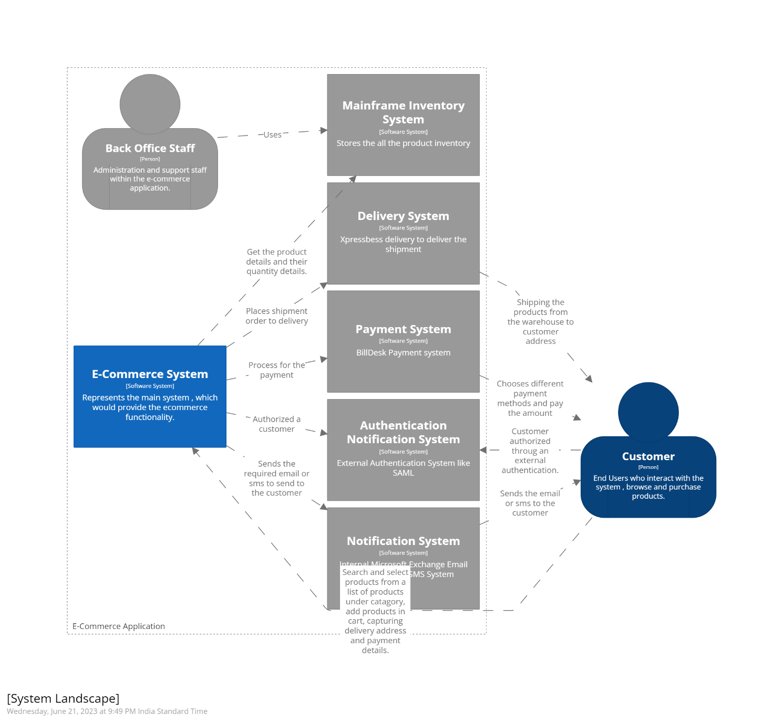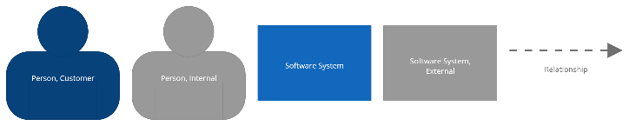

### Context View

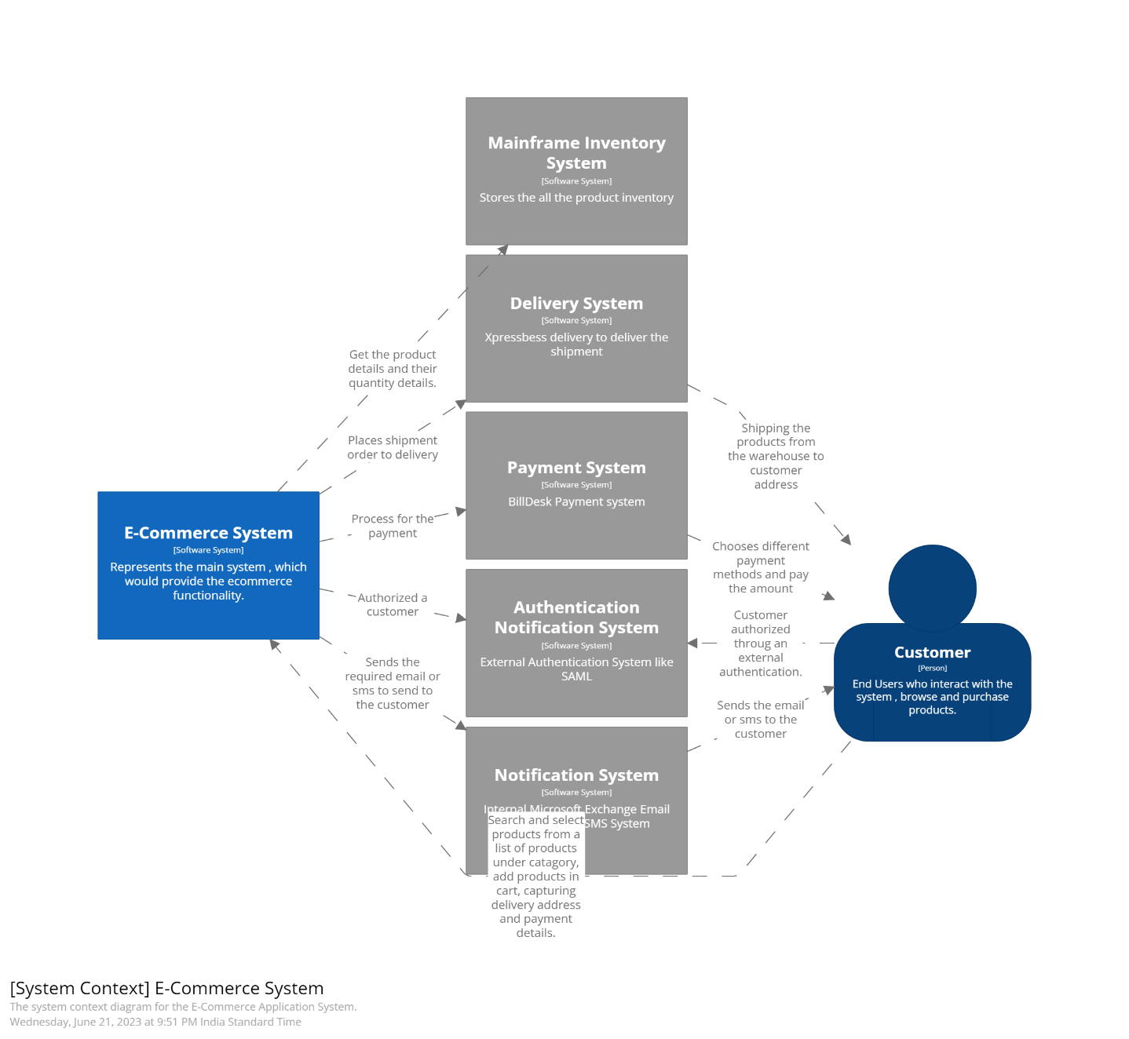

### Container View

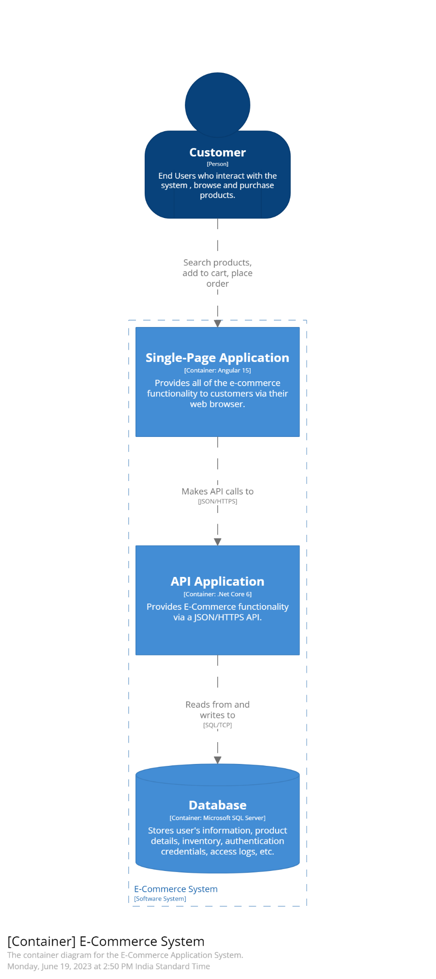



### Component View

### Deployment View (Development)

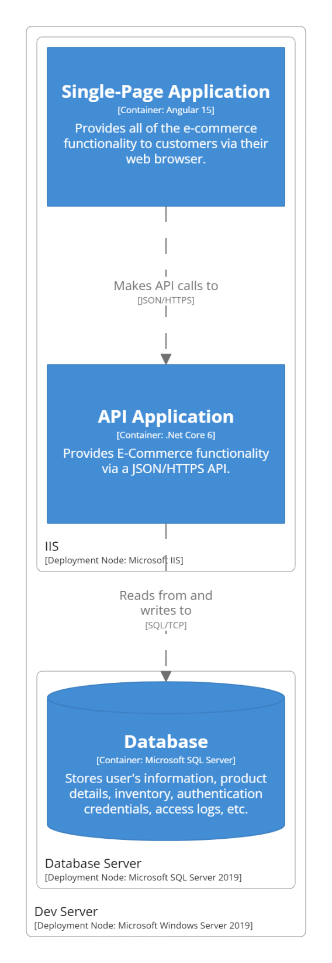

Deployment View (Production)

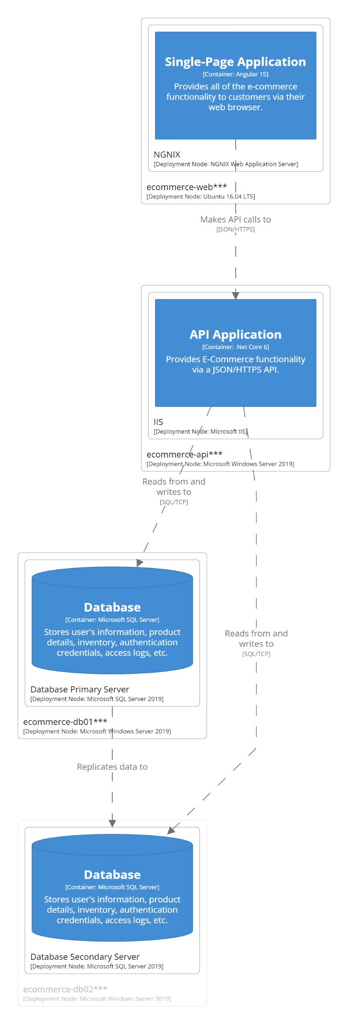

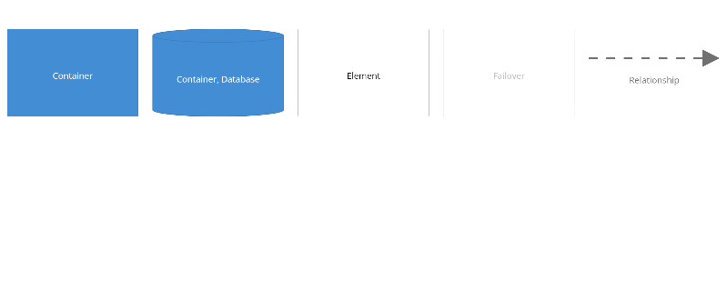

### ER Diagram:

